SAP Application Development

(S/4 HANA)

Introduction to SAP Programming

Motivation
The first chapter explains the main activities to set up the development environment and explore the different functions. Therefore, you will get in touch with ABAP in Eclipse, the integrated SAP GUI and the development tools which are offered by them.

Content
This chapter explains how to set up the development environment Eclipse for ABAP development. At first, it will be shown how to download and install the Eclipse IDE, followed by the installation of the ABAP plugin. Afterwards, the general functionalities of Eclipse will be explained. Finally, the integrated SAP GUI in Eclipse and its functionalities will be presented. The aim of the chapter is to get the students familiar with the Eclipse IDE for ABAP development, in order to use it for following implementation tasks.
Prerequisites
Before starting the exercises, you should have fundamental programming skills and be familiar with the basic navigation in a development environment such as Eclipse. Furthermore, you should have a current Java Development Kit (JDK) installed.

Lecture notes
All users need a developer key to be able to do the exercises. This key must be entered once when you connect to an SAP system via Eclipse. If you need developer keys, please contact your local UCC. A short guide on how to enter developer keys is provided in the separate lecture notes.

- Product: All

- Level: Beginner

- Focus: Programming

- Version: 2.0

- Author: UCC Technical University of Munich

Task 1: Download Eclipse development environment (IDE)
Short description: Downloading a current version of the Eclipse IDE through the website of the Eclipse project, installing and starting it.
Download and install Eclipse

Visit http://www.eclipse.org/downloads/packages/release/oxygen/3 and download a current version of the Eclipse IDE. We recommend to choose the Oxygen release, since it is ensured to be compatible with the ABAP and SAPUI5 plugins. Choose Eclipse IDE for Java EE Developers as version and download the package. You have to unzip the package and save it to a preferred folder. Afterwards, create a shortcut to the eclipse.exe file on your Desktop, which serves to easily start the Eclipse IDE.

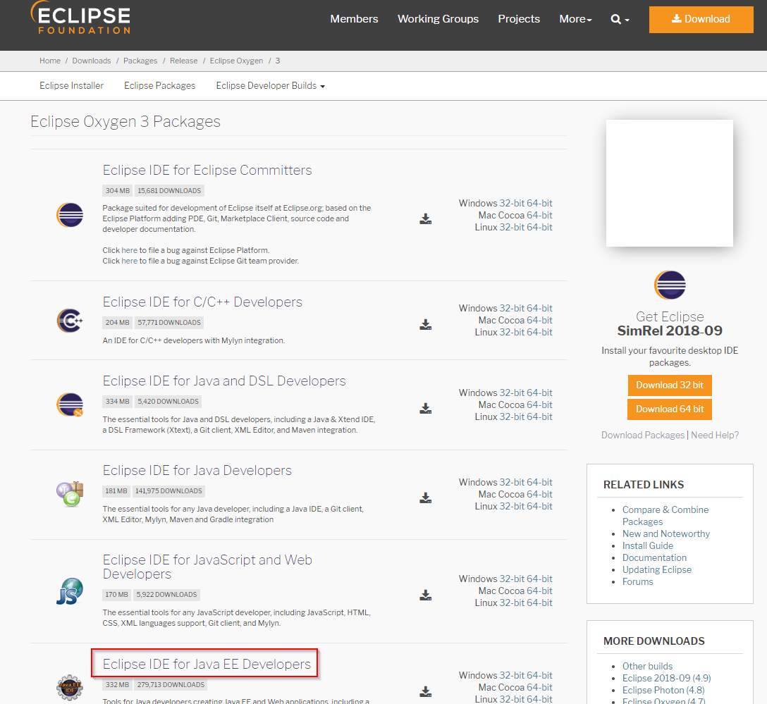

Start the Eclipse IDE with your created shortcut. You will be asked to choose a workspace. You can select any local folder. All local development projects and objects which are created in Eclipse will be stored in this folder.

Select workspace directory
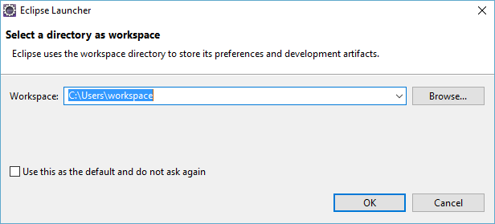

Close the welcome page. You will get to the central Eclipse User Interface (UI), which is initially empty.

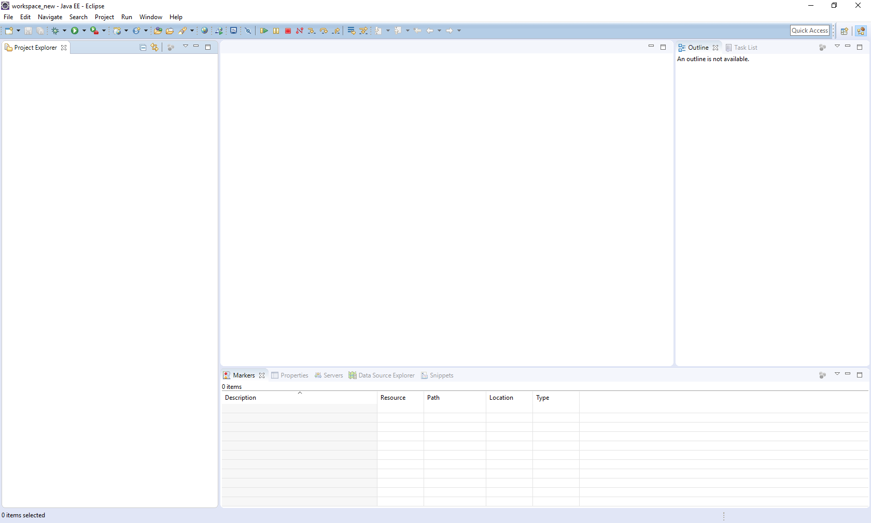

Task 2: Install ABAP plugin for Eclipse
Short description: Installation of an Eclipse plugin which allows the connection to an SAP system and the integration of ABAP development.

In the Menu Bar at the top of the UI, choose Help->Install New Software. In the appearing popup, click on Add, enter a name (e.g. ABAP for Eclipse) and the location https://tools.hana.ondemand.com/oxygen. Click on OK. A selection of possible plugins should appear.

Show available ABAP plugins for Eclipse
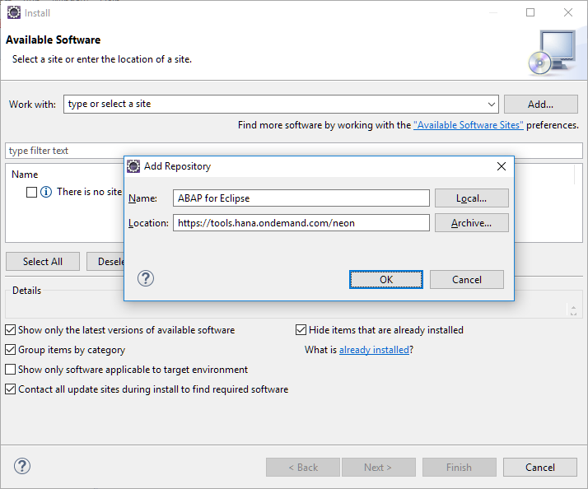
From the possible plugins, choose ABAP Development Tools for SAP NetWeaver and UI Development Toolkit for HTML5. Confirm your selected packages by clicking on Next, and go on in order to install the plugins. The installation process may take a few minutes. Finally, restart Eclipse.
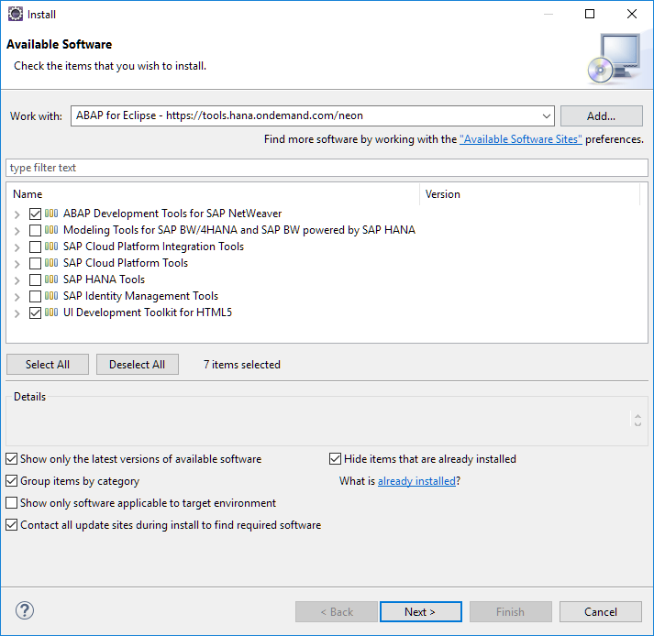
Choose the plugins to be installed

Task 3: Explore Eclipse IDE
Short description: Exploring the different menu areas of the Eclipse IDE and its functionalities

The Eclipse IDE has five central menu parts which are important in the context of SAP application development.

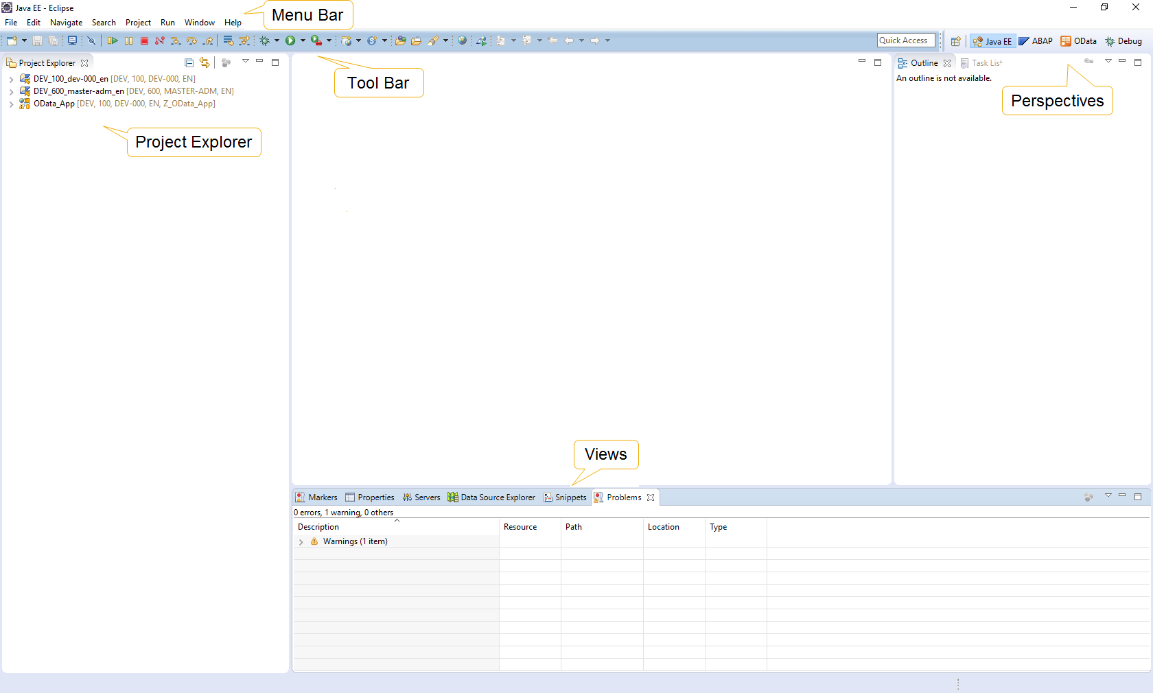

The Menu Bar is at the top of the UI and contains a variety of functionalities, e.g. with regard to UI layout, Eclipse settings, or the installation of new plugins. Furthermore, all functions to manage development projects, e.g. creating new projects, formatting source code, or testing and running applications, are available there. As already shown in the previous task, the installation of plugins is also done through the Help menu in the Menu Bar.

Open Menu Bar
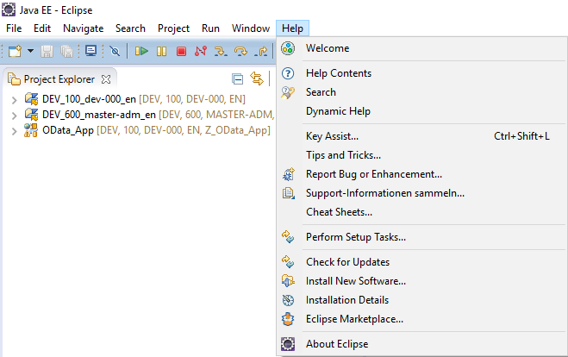

The Project Explorer is the central menu to manage projects. All development objects of a project are organized in a tree structure, in which you can break down the project structure and manage the different objects. Furthermore, the Project Explorer provides a context menu for all development objects. This context menu is started with a right-click on any development object, and provides different functionalities depending on the object. For instance, right-clicking on a source code object shows options such as renaming, debugging, or running the file. Moreover, the context menu of the empty Project Explorer (right-click on any empty space in the Project Explorer) has functions such as the creation of a new project.

View Project Explorer
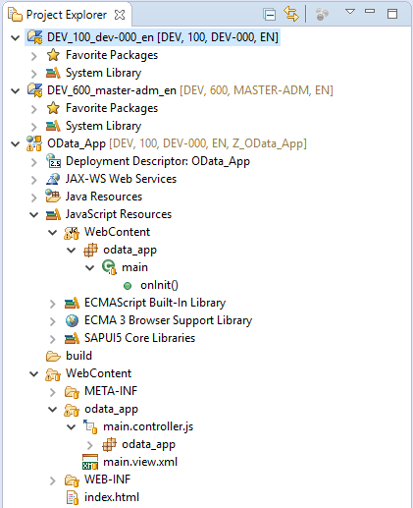

The Tool Bar contains different buttons which provide quick functionalities which are frequently used, such as running and debugging projects, saving source code files, or in the case of ABAP for Eclipse, a quick link to open the integrated SAP GUI.

The Views area contains different views which show project metadata, and allow users to monitor their projects. For instance, the Problems view shows problems and warnings during the program execution, or the Properties view shows property values of development objects. You can open additional views by choosing Window->Show View in the Menu Bar and selecting the view you want to open.

Open new Views
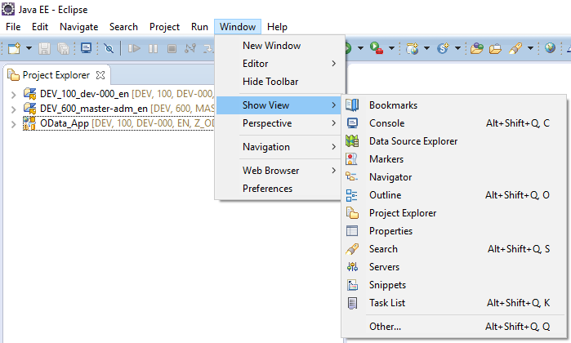

The different perspectives, which are shown at the top right, can be used to adapt the UI of Eclipse to specific needs. An eclipse perspective is an initial collection and arrangement of views, toolbar elements, and the Editor Area. For instance, when using the ABAP perspective for ABAP development, you get additional functions in the Tool Bar to open SAP repository objects, it provides a view to monitor ABAP repository objects, or you can manage transport requests for ABAP programs. A selection of perspectives which were already opened is shown at the top right of the Eclipse UI. You can open a new perspective either by adding it with the Open Perspective button next to it, or by choosing Window->Perspective->Open Perspective->Other, and selecting the view you want to show.

Open new Perspective
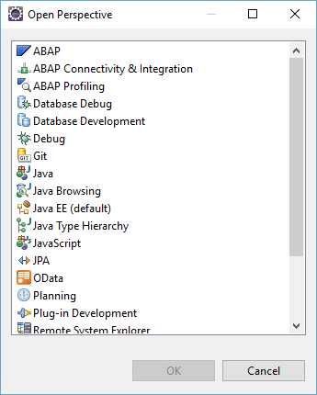

As we want to explore the ABAP perspective, which contains the integrated SAP GUI in the next task, please open the perspective by choosing one of the explained ways to do so. You will see that the UI slightly changes, except for the Editor Area.

The Editor Area is the central element of Eclipse. It shows open repository objects, source files, or project data. In the course of the development process, all editing of development objects, e.g. by adding new functionalities, is done through the Editor Area. Later on, you will notice that the Editor Area always changes according to the development object which is currently opened. Furthermore, for different source code files, code and syntax highlighting changes. This flexible Editor Area is a huge advantage of Eclipse and is a reason why it is used for a huge variety of programming languages and application development projects.

Task 4: Connect to an SAP system
Short description: Connecting to an SAP system through a new ABAP project, which serves as basis for ABAP development in Eclipse

In the context menu of the Project Explorer (Right-click), choose New->ABAP Project.

Create new ABAP project
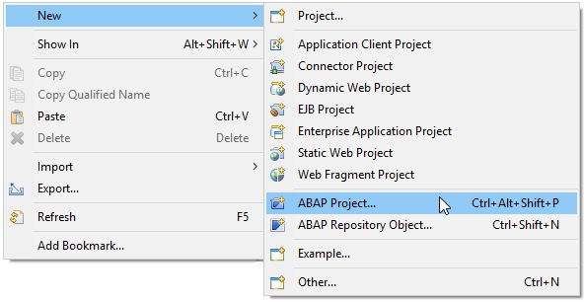
In the following screen, an overview of your connections to SAP systems is given. Select the development system which was provided to you and click on Next two times. Afterwards, login with your provided username and password and click on Finish.

Login to SAP system
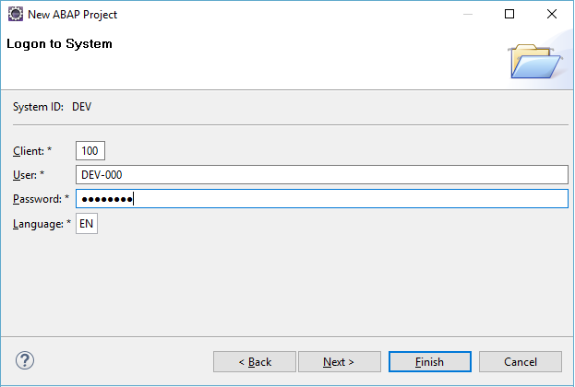

Task 5: Explore the integrated SAP GUI in Eclipse
Short description: Exploring the functions of the integrated SAP GUI in Eclipse

The ABAP project you created in the previous step will appear in the Project Explorer in Eclipse. You will see two subfolders of your project. The first one contains favorite packages of development objects, in order to access them more easily. The other one contains all development packages of the selected SAP system. Make sure that the ABAP perspective is selected on the upper right of the Eclipse UI. Afterwards click on the Open SAP GUI button in the Eclipse Tool Bar. Confirm the popup with OK. The integrated SAP GUI will appear in the Editor Area.

Open integrated SAP GUI
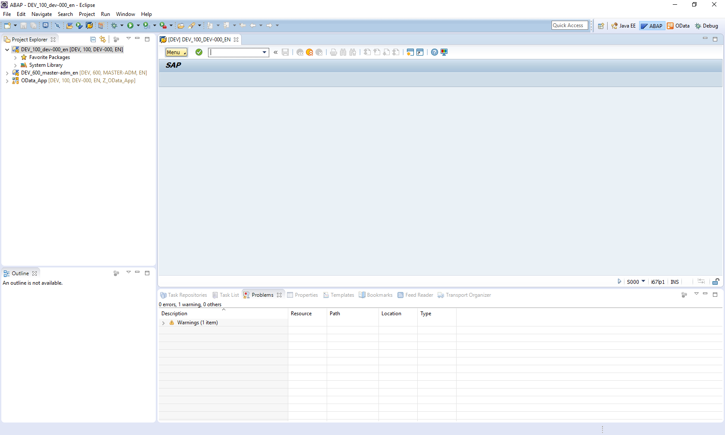

The integrated SAP GUI in Eclipse has three main menu areas which are relevant for ABAP development. First, there is the Application Toolbar. This toolbar contains several buttons to control an application program. For example, it contains the Back, Exit and Cancel buttons, which can be used to navigate within an application program. The Application Toolbar is program-specific and changes depending on which program is currently running in the SAP GUI.

Second, there is the field for Transaction Codes within the Application Toolbar. With this field, application programs within SAP can be directly called. For ABAP development, the mainly used transaction is the ABAP Development Workbench, which has transaction code SE80.

Third, there is the Menu Bar. On the left of the Application Toolbar, there is the Menu button. By clicking on it, the menu options are shown. This menu is also program-specific and can change depending on the current program.
Show Menu Bar

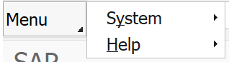

In order to explore the different menu areas, enter SE80 into the Transaction Code field and press Enter. The ABAP Development Workbench will show up.
Open ABAP Development Workbench
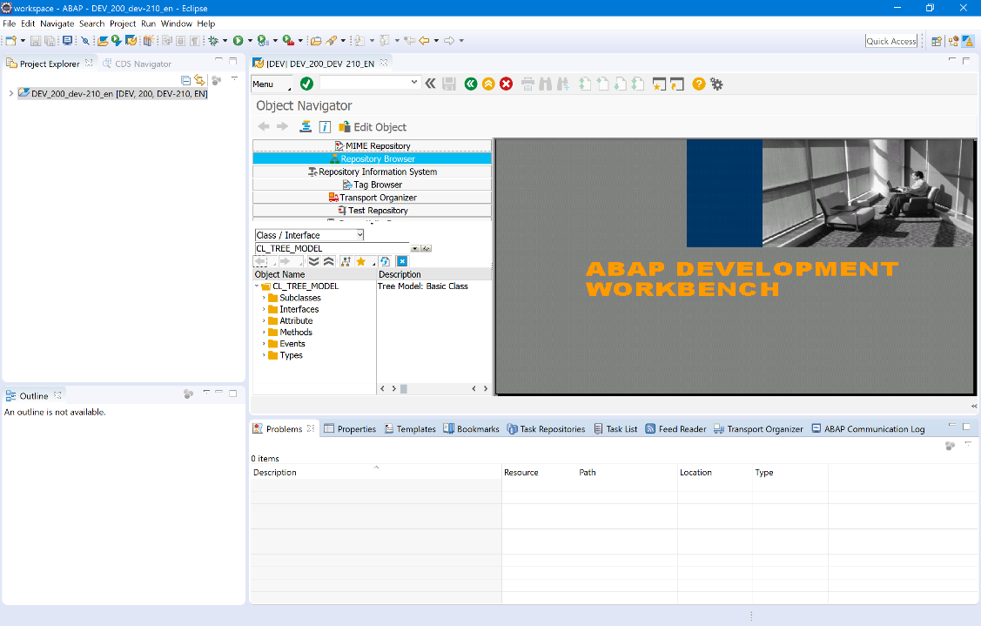

Close ABAP Development Workbench
As you can see, the active buttons in the Application Toolbar changed. Furthermore, when you click on the Menu button, you will notice that the Menu Bar also changed. Now it has a variety of options, which offer functions specific for the ABAP Development Workbench.

Click on the Exit button to end the transaction. Again, the starting page of the integrated SAP GUI will be shown.

Remark on ABAP for Eclipse: In general, the ABAP Development Workbench is still heavily used for ABAP development. Especially for traditional Report and Dynpro implementation, it is still the leading development environment. However, for the newer technologies such as SAPUI5, the ABAP Workbench is uncomfortable to use, for which reason, Eclipse is the mainly used for implementing such applications. Furthermore, also for traditional Report and Dynpro development, Eclipse provides benefits, such as better syntax highlighting and code completion. There are functions which are not (yet) available in the native Eclipse IDE, such as the creation of ABAP packages. For these tasks, Eclipse offers the integrated SAP GUI, which we presented in Task 5. Thereby, Eclipse is completely compatible with the traditional ABAP Workbench, and offers additional functionalities. Therefore, in the following case studies, we will use Eclipse as main IDE. If necessary, the integrated SAP GUI will be used to some extent. But in any case, Eclipse will be leading tool for working on the implementation tasks.

